User Guide for the Booking Experience

BlueRunner Solutions Hospitality Booking Platform

- Registration
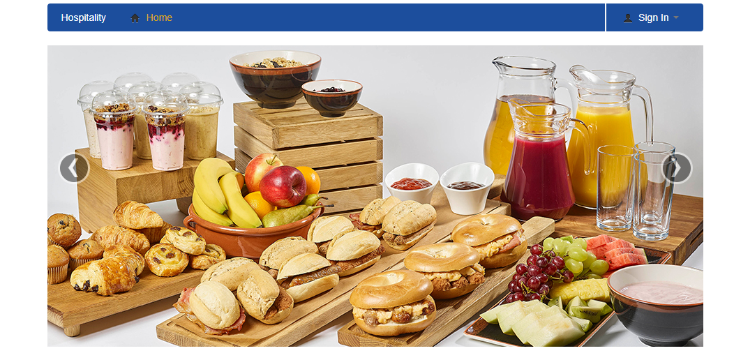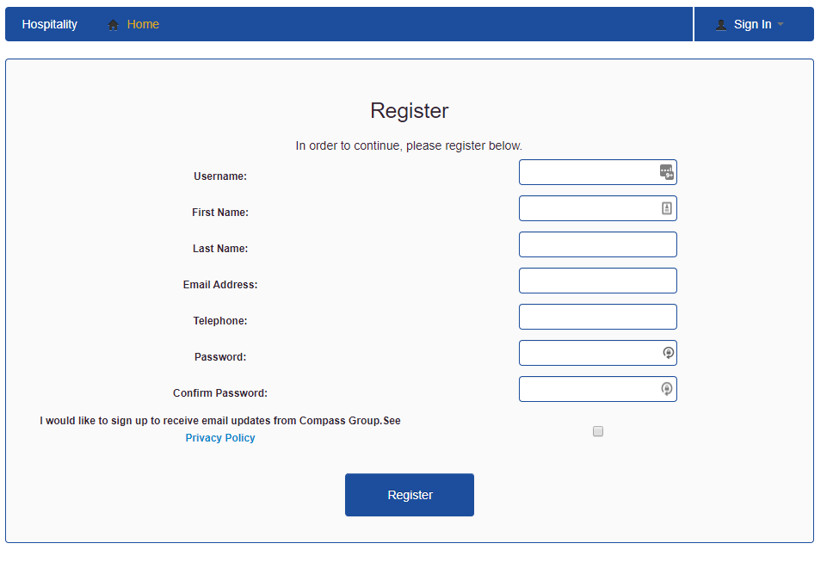
Select register and fill in the above form. Once completed you can log into the system using the chosen username and password
- Create a booking
After logging in the below page will appear
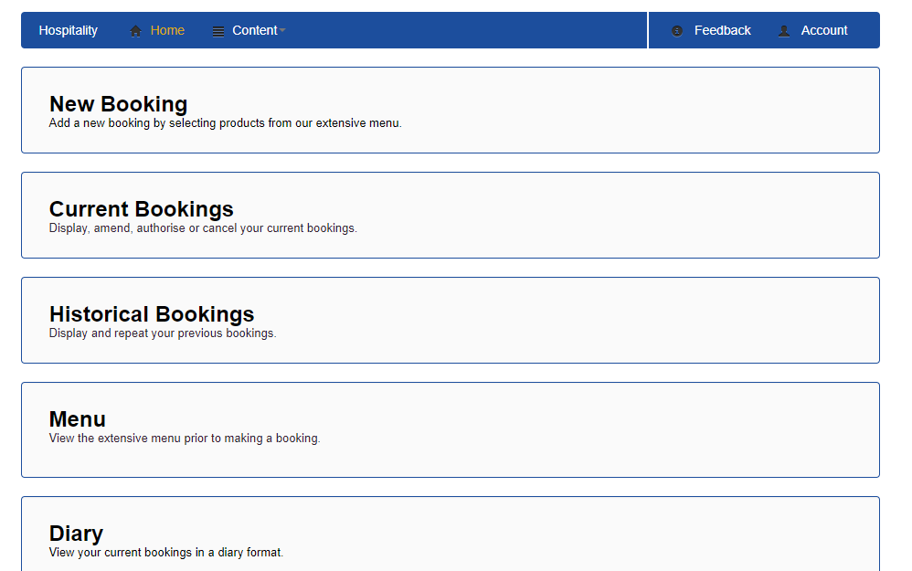

When you click on the new booking form you will find this message that will remind you on the booking restrictions
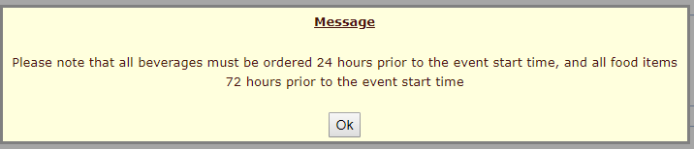
A new booking will take you to the below booking form

You will need to enter the Booking Status, Event Title and Location.
You can only select one location, but you will need to select a room or multiple rooms ticking the box.
When selecting the option of a recurring booking the above box allows the frequency to be selected and following that the end date of all of these recurring bookings- these will all be entered in the system as separate bookings but with the same offerings that have been added to the booking (can be adjusted within each separate booking if needed)
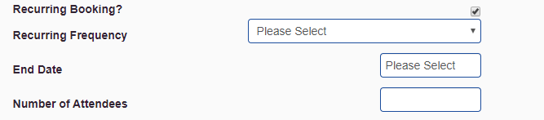
Cost Centre Code
Here you must choose the cost centre code that is defined by your management team.

- Adding menu items
When looking at the menu, you can see a range of products on offer, all of which are customisable through back of house management. You can also leave special requirements and descriptions of bespoke items needed. The user can also select the time for the offer to be brought to the room, and if 1 booking is over multiple rooms the room can also be selected.
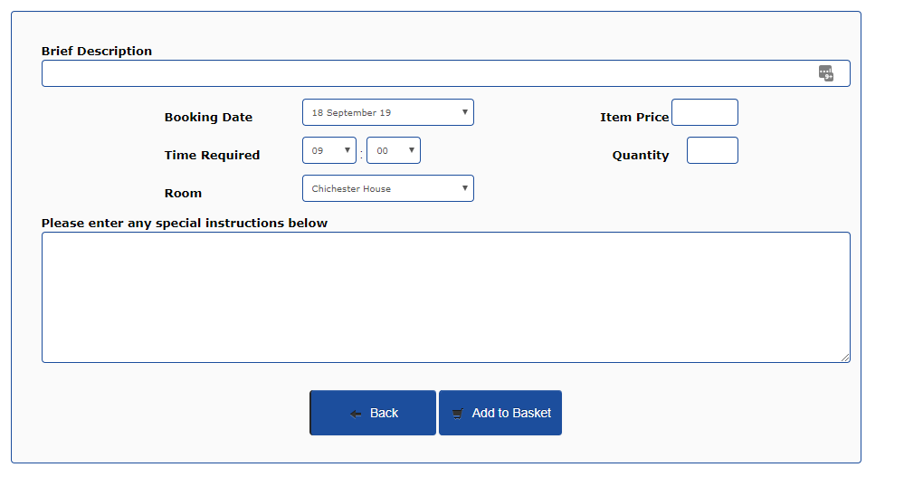
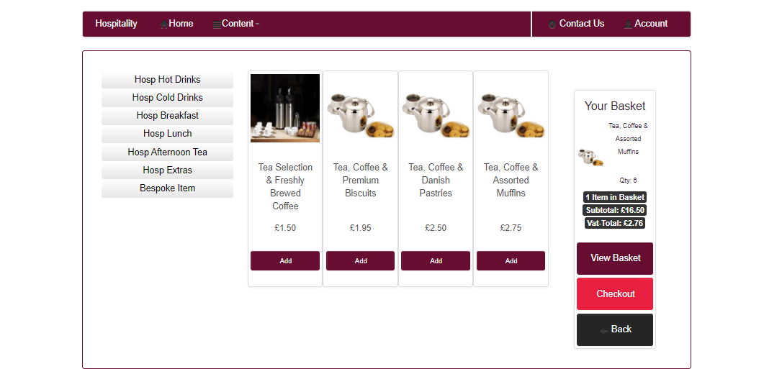
Whilst adding items to the basket, your running total in terms of items, quantity and total price amount will always be on the right hand side of the screen

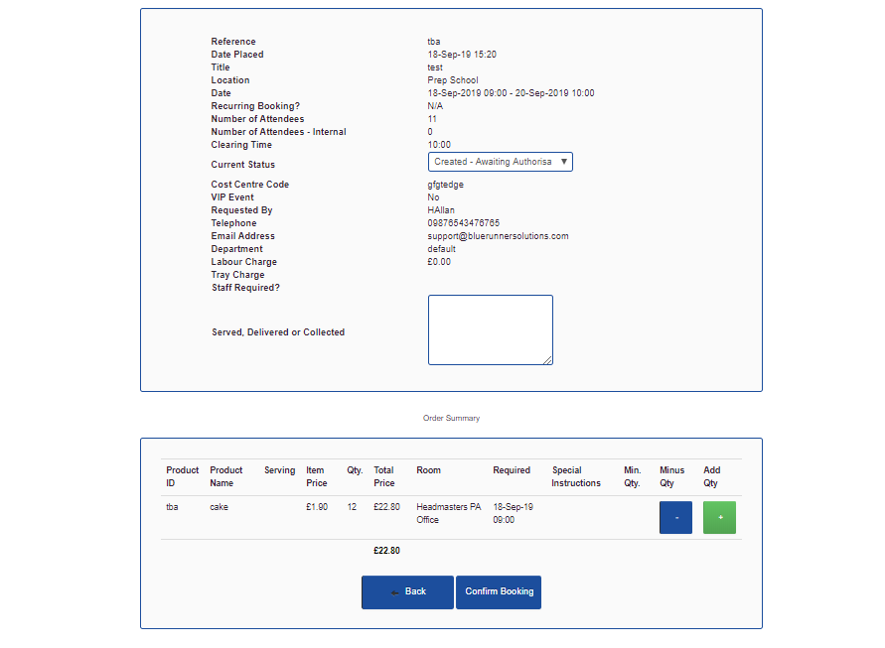

Once the order is completed, the user has an option to review and edit the order to help reduce error. If adding extra quantity (with green + button) then the running total amount of the basket will automatically increase accordingly

Current bookings:
Here you will be able to see your upcoming bookings, see their current status or modify them.
Select the + of booking you wish to Modify (will see a similar page as when opening a historical booking) Select modify which will bring you back into that booking
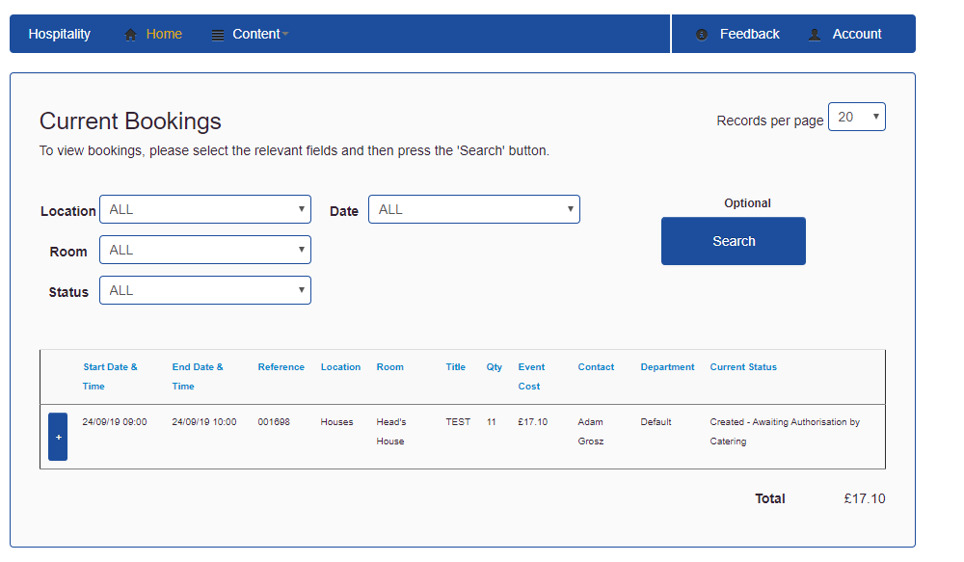
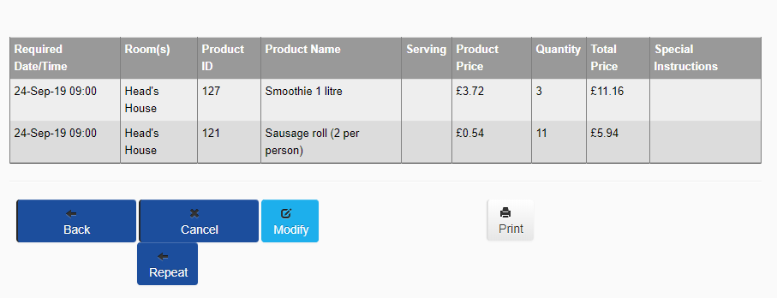
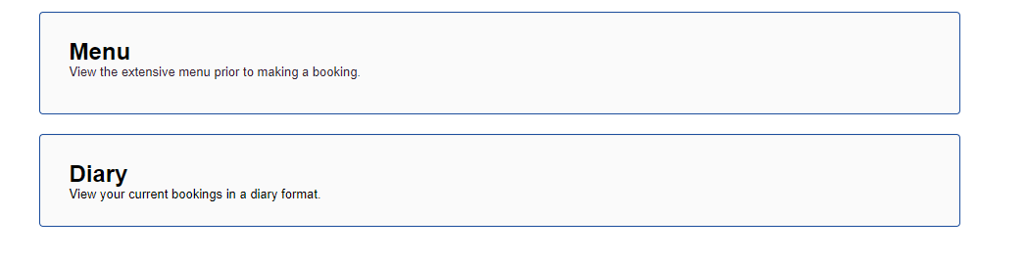
Historical bookings not only allow users to check the status of any booking previously made, but it also enables users to repeat a previous booking within seconds. (enter the booking with the + to see the below page)
Menu & Diary The final two options you have as a user is the ability to view the menu – this gives you the option to browse the menu without entering the booking information first.
The diary view gives you another way to view all future bookings in a diary format for customers to select and view bookings created.

