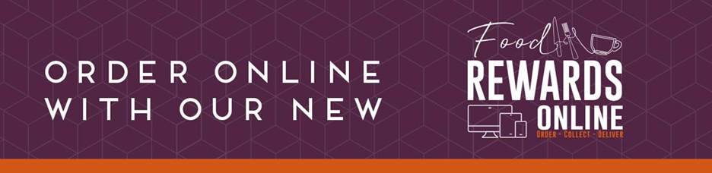

Register to Food Rewards Online Click & Collect

* Open the attached link with Google Chrome <https://food-rewards.com/stfc-r22>
* Sign Up and register.
* A verification email will be sent to your address (check your spam folder if you don’t receive it within 5 minutes)
* Copy and paste the verification Hyperlink to Google Chrome to complete the registration.
* Location number 3847
* Save Food Rewards Online home page to your bookmarks for future use
* You will find the R22 click and collect opening hours and weekly menu on the home page for reference.
* Click on “Order Now” to place an order and Pay online
* Collect from R22 and Enjoy your meal

